Quick Start Guide

This guide will help you quickly get started with SUN. For more detailed information on SUN, please refer to the SUN Manual – English.

1. Download and print the Character Cards and Extension Cards on heavy paper.
2. Cut the printed cards along the green lines as shown in the picture below. Fold the card along the purple line. One side of the card will have the symbol. The other side will have the picture and meaning.

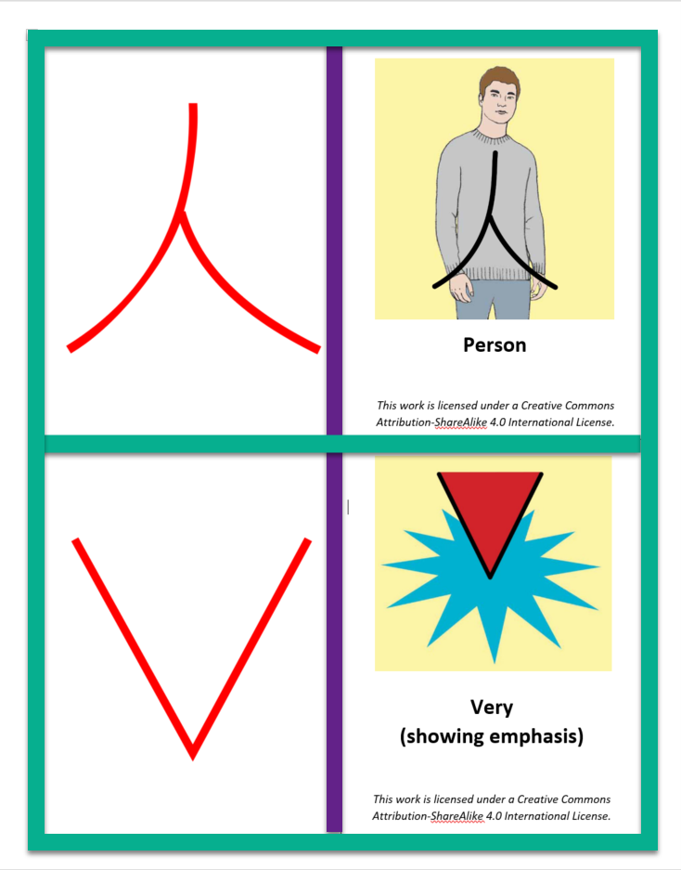

1. Download and open the Reader’s Dictionary. This will help you understand the Extension Cards.
   1. The Table of Contents contains the Character Cards that are used to make Extension Cards.
   2. Example: The symbol for Man is used to make the symbols for Boy, Father, Son, etc.

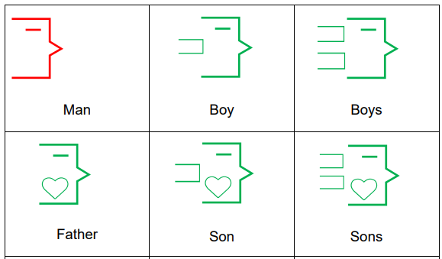

1. Download and open the Facilitator Instructions. Use the Facilitator Instructions to help you teach the Home Sign Lessons.
2. When you have completed teaching the Facilitator Instructions, download and open Sample SUN Scripture – Mark 1. This is Mark Chapter 1 translated in SUN.
3. When you are ready to teach scripture, download and open the Creating New Lessons.